**IAR + SmartBox NILM V 0.2 User Manual**

**Part 1. Setup**

1. Plug IAR Systems board power supply to 220 AC socket.
2. Plug in SmartBox to 220 AC socket.
3. Ensure IAR RS232 port is connected to SmartBox RS232 port.
4. Ensure Ethernet cable between client PC and host IAR is connected.
5. Ensure that the client PC Ethernet ip is set to static 192.168.0.99 and default netmask 255.255.255.0

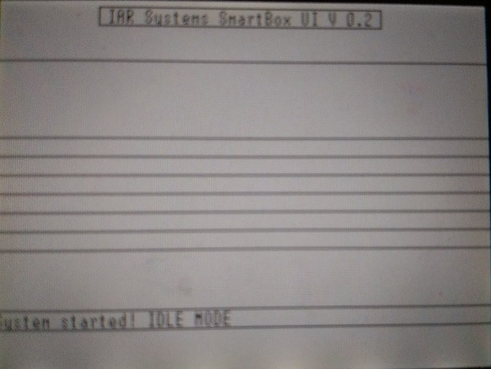**Part 2. UI**

1. If after the startup you see the Layout of the GUI but no text or data, the Ethernet connection is not established properly. Please check your Ethernet cable connection and static ip. Once properly connected the GUI should be fully loaded.
2. 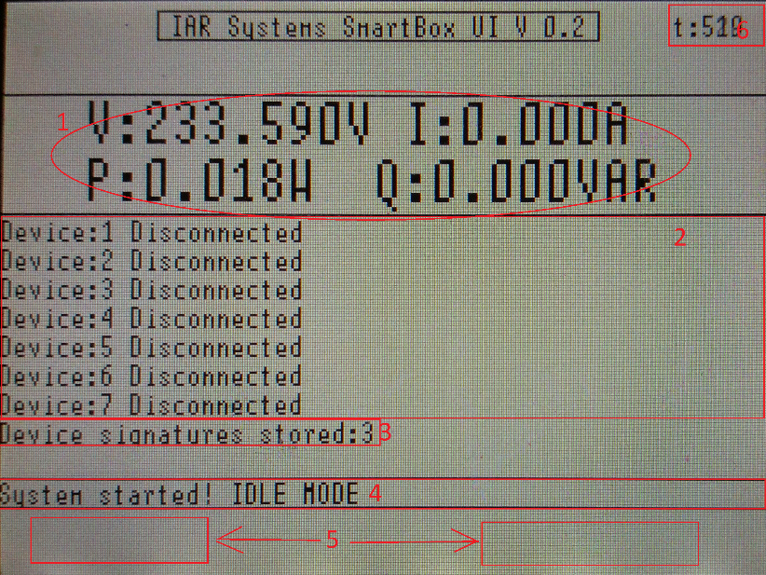GUI description

1. Main measurements area displaying Voltage, Current, Active and Reactive Powers

2. Device list table. Displays the status of devices, Disconnected by default, when active displays approximated device consumption.

3. Informs the user how many device signatures are stored in device at the moment

4. “Status bar” Displays the last event message.

5. Area where yes and no buttons appear when needed.

6. Timer used for debugging purposes.

1. By default 3 devices signatures are hardcoded: LAMP , FAN MODE 3, Solder Iron(will take it home). So start by turning on 1 of the available devices.
2. On the status bar the change of power which triggered device recognition will be displayed.
3. The system wait 2 seconds for measurements to stabilize a bit, next it will observe device behavior for 6 seconds, noticing the peak values and calculating average values over time.
4. Next, if the device behavior matches one from the devices signature list, the device status will change to connected and approximated data will be shown for specific device.
5. If device behavior did not match any from the list, the user will be prompted to add new device to the list or not.
6. Now you can connect another device, or disconnect the connected one. Please do it 1 by 1 with 10 sec intervals.
7. In order to check “learning mode” the timer area serves as delete all signatures button. So grab a pen or another pointy object and click it until you see “all signatures deleted” message. Now device has 0 devices stored. It is advised to do it at program start.

**Part 3. Web**

1. Open your browser of choice (tested on: Chrome)
2. Open address 192.168.0.100.
3. You should see main page.
4. Observe the graphs to monitor the behavior.